Project Report
On
eAuto – Bike Spare Parts E-Commerce Platform PHP
In partial fulfillment for the award of the degree Of
BACHELOR OF COMPUTER APPLICATION
[B.C.A]
Year 2025-2026
SUBMITTED BY: | GUIDED BY:
Dhruv Dholiya (1234) | Prof. Bipin Jadhav
Dharmik Dobariya (1234)
Vatsal Kapadia (1234)

BCA-5th SEMESTER
Submitted to:

SHRI SHAMBHUBHAI V. PATEL COLLEGE OF
COMPUTER SCIENCE & BUSINESS
MANAGEMENT
Affiliated to
Veer Narmad South Gujarat University



Acknowledgment
- We take this opportunity to express our deep sense of gratitude to all those who have supported and encouraged us throughout the completion of our project, “eAuto – Bike Spare Parts E-Commerce Platform”.
- First and foremost, we would like to express our sincere thanks to our respected guide, Prof. Bipin Jadhav, for his valuable guidance, constant encouragement, and continuous support. His expert supervision, constructive suggestions, and insightful feedback have been instrumental in shaping our project into its present form. It was truly a privilege to work under his guidance.
- We also extend our heartfelt thanks to all the professors of our college for their cooperation, encouragement, and for always being ready to provide solutions whenever required.
- A special thanks goes to our friends and colleagues for their timely help and constant support, which played an important role in the successful completion of this project.
- Finally, we sincerely acknowledge the efforts and collaboration of our team members:
  - Dhruv Dholiya (1234)
  - Dharmik Dobariya (1234)
  - Vatsal Kapadia (1234)

Index
SR.NO | PARTICULAR | PAGE NO
1 | INTRODUCTION
 | 1.1 Project Profile
 | 1.2 About Project
2 | SYSTEM ENVIRONMENT
 | 2.1 Hardware Used
 | 2.2 Software Used
3 | PROBLEM SPECIFICATION
 | 3.1 Introduction, Objective and Purpose
 | 3.2 System Model
 | 3.3 Feasibility Study
 | 3.3.1 Technical Feasibility
 | 3.3.2 Economic Feasibility
 | 3.3.3 Operational Feasibility
 | 3.3.4 Behavioral Feasibility
4 | RISK IDENTIFICATION AND MANAGEMENT
 | 4.1 Risk Monitoring
 | 4.2 Risk Assessment
 | 4.3 Risk Management
5 | TECHONOLOGY USED FOR DEVELOPMENT
6 | PLANNING
 | 6.1 System Planning
 | 6.2 System Flow Chart
7 | SYSTEM ANALYSIS
 | 7.1 Database Design
 | 7.2 ER Diagram
 | 7.3 Data Flow Diagram
 | 7.4 Data Dictionary
8 | DESIGNING
 | 8.1 User Interface
 | 8.2 Admin Interface
9 | TESTING
 | 9.1 Software Testing
 | 9.2 Unit Testing
 | 9.3 System Testing
10 | REFERENCE



The eAuto – Bike Spare Parts E-Commerce Platform is a web-based application developed using PHP and MySQL that provides an online marketplace for bike spare parts.
This system is designed to simplify the process of purchasing spare parts for different brands and models of bikes by offering a user-friendly interface, real-time inventory management, and secure transactions.
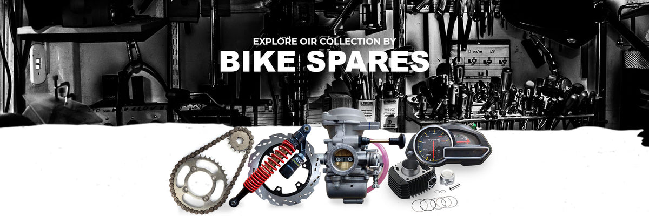
The platform addresses the challenges of the traditional offline market such as limited availability, lack of price comparison, and difficulty in finding genuine parts. Through this system, customers can conveniently search, compare, and order spare parts online, while administrators can efficiently manage inventory, orders, and users.



1.1 Project Profile
The eAuto – Bike Spare Parts E-Commerce Platform is a web-based application developed using PHP, MySQL, HTML, CSS, Bootstrap, and JavaScript. The system is designed to provide an online marketplace for purchasing bike spare parts in a simple, fast, and user-friendly way.
In today’s digital world, customers prefer the convenience of shopping online rather than visiting physical stores. Traditional methods of purchasing spare parts involve time-consuming visits, limited product availability, and lack of real-time inventory updates. To overcome these drawbacks, this project aims to deliver a modern, responsive, and secure platform that bridges the gap between customers and spare part vendors.
The system supports two main modules:
- User Module (Customers): Allows browsing products, searching by brand/category, adding products to cart, managing delivery addresses, placing orders, and tracking order history.
- Admin Module (Vendors/Administrators): Provides functionality to manage products, categories, brands, stock, and customer orders.
This project is developed as a part of BCA (Bachelor of Computer Applications) Final Year Project, focusing on applying theoretical knowledge into a practical real-world solution. It demonstrates skills in database design, backend development with PHP, frontend designing with Bootstrap, and integration of system functionalities into a working e-commerce platform.

1.2 About Project
The eAuto Platform is specifically designed for bike spare parts and caters to brands like Honda, Hero, Bajaj, Yamaha, and others. The system provides customers with a wide collection of parts such as CDI Units, Headlight Sets, Self Starter Motors, Silencers, Speedometers, Wheel Rims, and more.

Key Features of the Project:
- User Side:
  - Registration/Login system for secure access.
  - Browse products by brand, category, and collection.
  - Add to Cart, Update Quantity, and Remove Item features.
  - Manage delivery addresses with default address selection.
  - Checkout process with order summary and order confirmation.
  - Order history and profile management.
- Admin Side:
  - Add, update, delete products with details (brand, category, price, stock, discount, image).
  - Manage customers, their orders, and delivery addresses.
  - Monitor stock availability and update product information.
  - Generate reports of products and orders.

Technology Used:
- Frontend: HTML, CSS, Bootstrap, JavaScript
- Backend: PHP
- Database: MySQL (phpMyAdmin – XAMPP)
- Server Environment: Apache (XAMPP)

Advantages of the Project:
- Provides a centralized online platform for buying bike spare parts.
- Saves time and effort compared to offline purchases.
- Real-time stock management and product availability updates.
- Improved user experience with a responsive and modern interface.
- Admin-friendly dashboard for efficient product and order management.
In conclusion, the project eAuto – Bike Spare Parts E-Commerce Platform is an effort to build a reliable, scalable, and practical solution that meets the requirements of both customers (who want easy and quick access to spare parts) and administrators (who need a powerful system to manage inventory and sales).
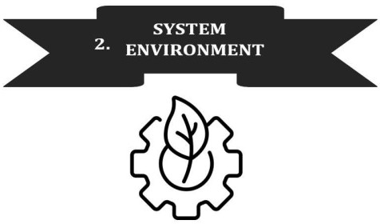
Great 👍 Now let’s prepare your SYSTEM ENVIRONMENT section for your PHP-based project documentation. This part explains the hardware and software requirements for developing and running your eAuto – Bike Spare Parts E-Commerce Platform.
Here’s the full content:

The system environment defines the hardware and software requirements that are essential for developing, deploying, and running the eAuto – Bike Spare Parts E-Commerce Platform. Since the project is developed using PHP, MySQL, and XAMPP, the requirements are simple and cost-effective, making it suitable for academic as well as real-world use.

2.1 Hardware Used

Minimum Requirements (for Development & Deployment):
- Processor: Intel Core i3 / AMD equivalent
- RAM: 4 GB
- Hard Disk: 250 GB (with minimum 1 GB free for project files & database)
- Monitor: 15” VGA Color Monitor
- Keyboard: Standard 104 Keys
- Mouse: Optical Mouse
- Network: Basic LAN/Wi-Fi connection for online access and local testing

Recommended Requirements (for Smooth Performance):
- Processor: Intel Core i5 or higher / AMD Ryzen equivalent
- RAM: 8 GB or more
- Hard Disk: 500 GB or more (SSD Preferred)
- Monitor: 19” or higher LED Monitor (for better UI testing)
- Keyboard & Mouse: Standard or Wireless Combo
- Network: High-speed Internet connection for online deployment & API usage

2.2 Software Used
The project is built using open-source software tools that are easily available and widely used in PHP development.

Operating System:
- Windows 10 / 11 (for development using XAMPP)
- Linux / Ubuntu (for deployment on servers)

Backend Development Tools:
- PHP 8.0+ – Core server-side scripting language for handling logic, cart, checkout, sessions, and database connectivity.
- MySQL 8.0+ – Relational Database Management System (RDBMS) used to store user details, products, orders, and admin data.
- Apache Server (XAMPP) – Local server used for testing and running PHP code.

Frontend Development Tools:
- HTML5 – For structuring web pages.
- CSS3 – For styling and layout design.
- Bootstrap 5 – For responsive design and mobile-friendly UI.
- JavaScript (ES6) – For client-side validation and interactivity.

Supporting Tools:
- XAMPP – Integrated package containing Apache, MySQL, and PHP for local development.
- phpMyAdmin – Web-based interface for managing MySQL database.
- VS Code / Sublime Text – Code editor used for development.
- Browser: Google Chrome / Mozilla Firefox (for testing & running the project).



